JOINING THE LIVE WEBINAR EVENT

Step 1: Click URL Link in confirmation email

You will have received from Zoom a confirmation email. Approximately 15 minutes prior to the live webinar event, click the CLICK HERE TO JOIN link that is provided in the email from zoom (as shown below).

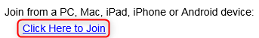This link can work from either your PC, Mac, Tablet or Android devices. For a full list of system requirements, please refer to our online help page here

(Steps continue on the next page)

Step 2: Install the Zoom webinar launcher (only needs to be completed the first time you use
Zoom)

After you click the join button from Step 1, if you are a first time Zoom user, you will be prompted to download and install the launcher. The
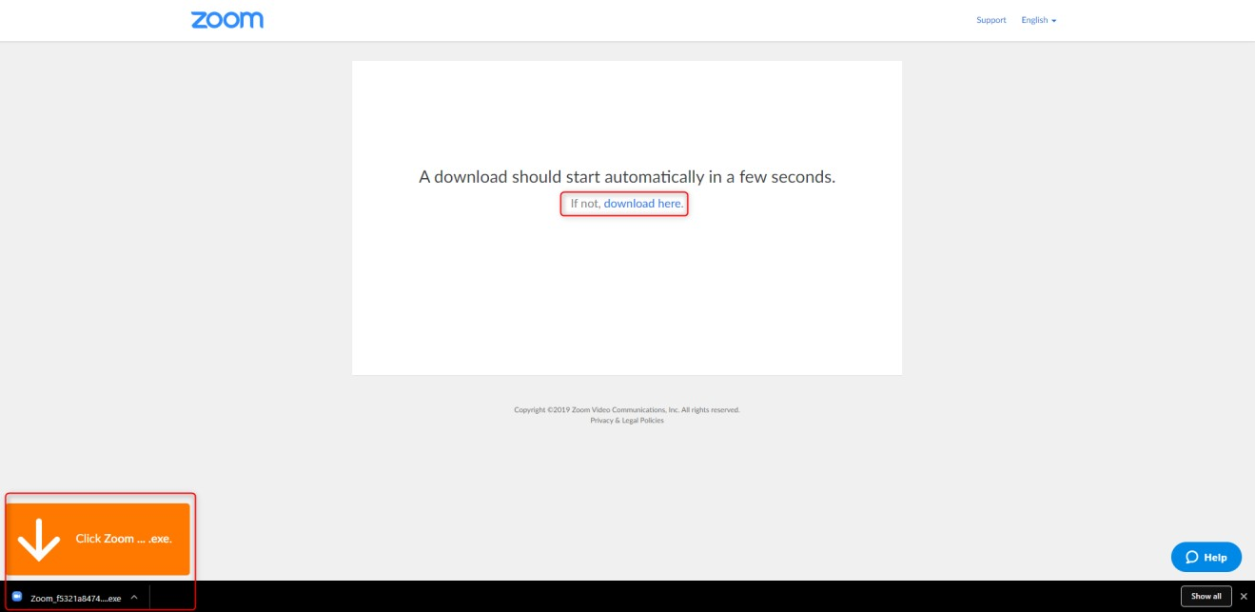download should begin automatically, however if this doesn’t happen, click the download link available on the screen (see screenshot below).

Open the Zoom Download File

Once downloaded, open the Zoom_launcher.exe file (check with your internal IT department if you can open these files) from the downloads bar at the bottom of your browser. If this is not shown, navigate to the downloads folder on your computer.

Run the program file

If you are prompted with an Open File-Security Warning dialog pop up box, select Run and then ok

Step 3: Check Audio Settings

Before the webinar begins, you can check that all your audio settings are working and setup correctly. On the “Please wait for the host to start this webinar” screen, select at the bottom the Test My Speaker button. This will then bring up the audio options allowing you to test your audio settings.

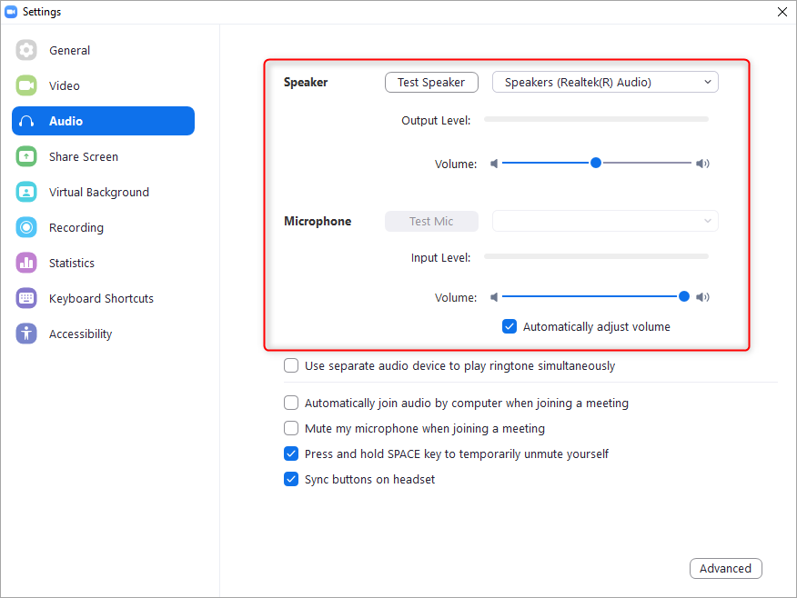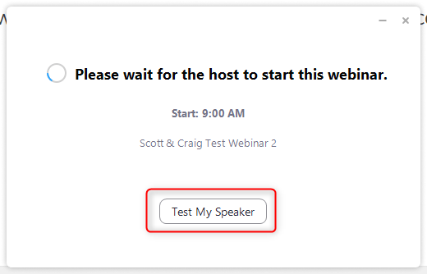

Step 4: Zoom Webinar Interface

When the webinar begins you will either be shown a Starting Soon slide or the Slide Presentation Title slide (as shown below). Leading up to the start of the webinar, audio tests will be conducted to make sure you’re able to hear via your selected audio method. All attendees are placed on mute so that there are no audio distractions for the presenter.

CTA TRAINING ZOOM WEBINAR – ATTENDEES
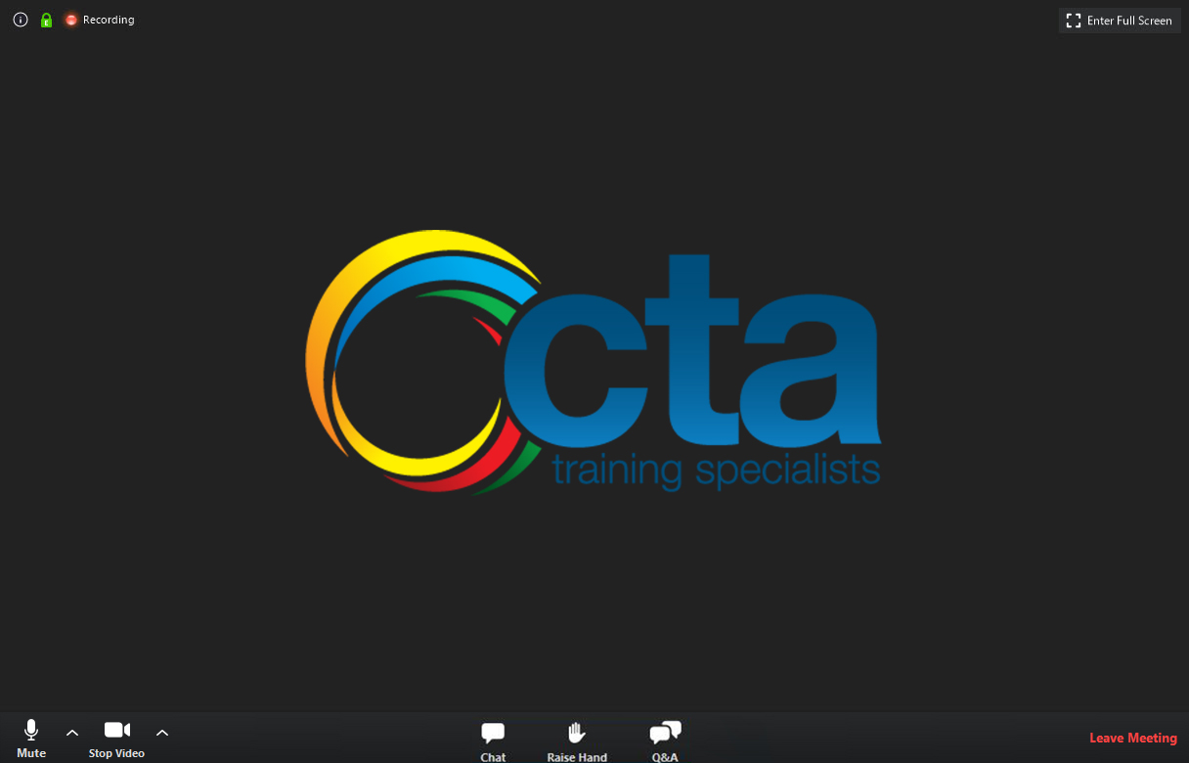

At the bottom of the screen in the dark bar, you will see three icons (Please Note: different presenters may require some of the functionally to be turned off/on so may look different from the screen above). These are listed below in more detail:

Chat Icon

Click the Chat icon to open the Chat dialog box. Via this window you can chat with either the Facilitator, Presenter or other attendees.

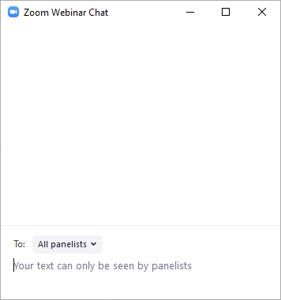

Raise Hand Icon

Clicking the Raise Hand icon will flag the Facilitator and turn the icon green. This is used if you require further help, are prompted to do so via a presentation slide or would like to be made unmuted so that you can chat with the presenter via your audio method.

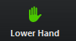If you like to lower your hand, simply click the icon again.

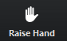

Q&A Icon (not used on every webinar)

Clicking the Q&A icon will open the Question and Answer window. Via this window you can ask either the Facilitator or Presenter a question for answering. Simply type your question in the box at the bottom and hit the enter key.

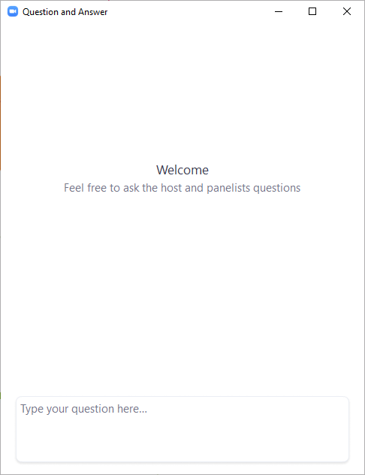

Polls

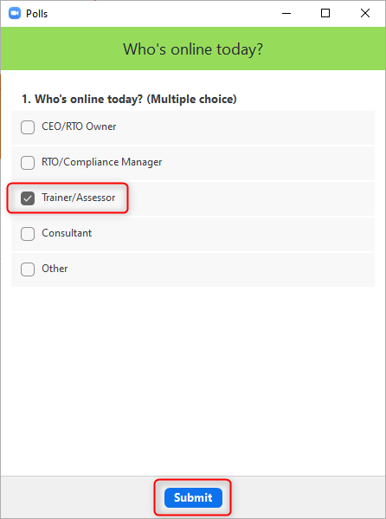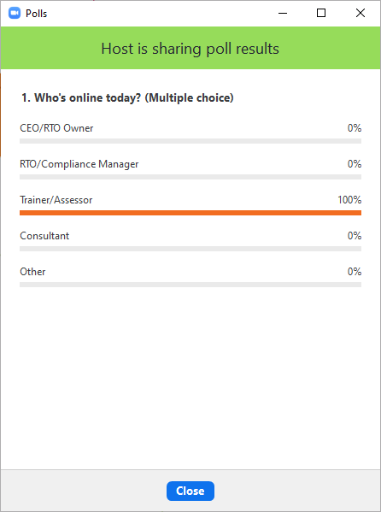On some webinars you will be asked to participate in polls. When a poll is launched by the Facilitator you will see this appear on your screen. From the options provided, simply click one and then click the Submit button at the bottom of the window. Once the submissions have been collected from the attendees, the Facilitator will display the results on the screen.

